This Python topics from basics to advanced (like Web-scraping, Django, Deep-Learning, etc.) with examples.

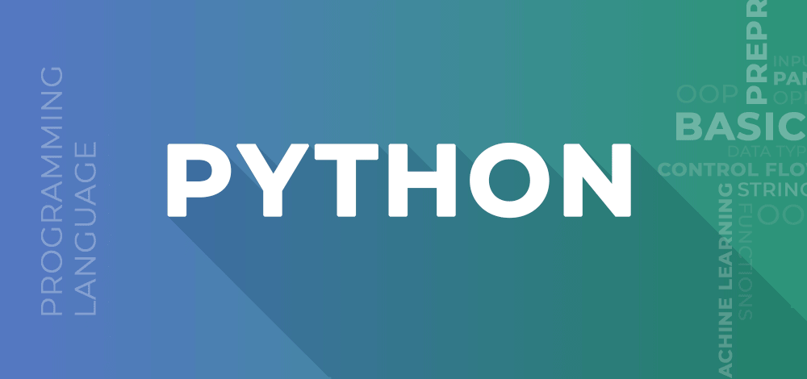

**What is Python?**

Python is a high-level, general-purpose, and very popular programming language. Python programming language (latest Python 3) is being used in web development, Machine Learning applications, along with all cutting-edge technology in Software Industry.

Python language is being used by almost all tech-giant companies like –

* Google,
* Amazon,
* Facebook,
* Instagram,
* Dropbox,
* Uber… etc.

The biggest strength of Python is huge collection of standard library which can be used for the following:

* [Machine Learning](https://www.geeksforgeeks.org/machine-learning/)
* GUI Applications (like [Kivy](https://www.geeksforgeeks.org/kivy-tutorial/" \t "_blank), Tkinter, PyQt etc. )
* Web frameworks like [Django](https://www.geeksforgeeks.org/django-tutorial/) (used by YouTube, Instagram, Dropbox)
* Image processing (like [OpenCV](https://www.geeksforgeeks.org/opencv-python-tutorial/), Pillow)
* Web scraping (like Scrapy, BeautifulSoup, Selenium)
* Test frameworks
* Multimedia
* Scientific computing
* Text processing and many more..

**Why Learn Python?**

Python is currently the most widely used multi-purpose, high-level programming language, which allows programming in Object-Oriented and Procedural paradigms. Python programs are generally smaller than other programming languages like Java. Programmers have to type relatively less and the indentation requirement of the language, makes them readable all the time.

[Python](https://www.geeksforgeeks.org/python-programming-language/) is a widely used general-purpose, high level programming language. It was created by Guido van Rossum in 1991 and further developed by the Python Software Foundation. It was designed with an emphasis on code readability, and its syntax allows programmers to express their concepts in fewer lines of code.

Python is a programming language that lets you work quickly and integrate systems more efficiently.

There are two major Python versions: **Python 2 and Python 3**. Both are quite different.

## Beginning with Python programming:

### 1) Finding an Interpreter:

Before we start Python programming, we need to have an interpreter to interpret and run our programs. There are certain online interpreters like [**https://ide.geeksforgeeks.org/**](https://ide.geeksforgeeks.org/) that can be used to run Python programs without installing an interpreter.

**Windows:**There are many interpreters available freely to run Python scripts like IDLE (Integrated Development Environment) that comes bundled with the Python software downloaded from [**http://python.org/**](http://python.org/).

**Linux:**Python comes preinstalled with popular Linux distros such as Ubuntu and Fedora. To check which version of Python you’re running, type “python” in the terminal emulator. The interpreter should start and print the version number.

**macOS:**Generally, Python 2.7 comes bundled with macOS. You’ll have to manually install Python 3 from [**http://python.org/**](http://python.org/).

### 2) Writing our first program:

Just type in the following code after you start the interpreter.

|  |
| --- |
| # Script Begins    print("GeeksQuiz")    # Scripts Ends |

Output:

GeeksQuiz

Let’s analyze the script line by line.

***Line 1: [*# Script Begins]**In Python, comments begin with a #. This statement is ignored by the interpreter and serves as documentation for our code.

***Line 2: [print(“GeeksQuiz”)]***To print something on the console,

* print() function is used.
* This function also adds a newline after our message is printed(unlike in C). Note that in Python 2, “print” is not a function but a keyword and therefore can be used without parentheses.
* However, in Python 3, it is a function and must be invoked with parentheses.

***Line 3: [*# Script Ends]**This is just another comment like in Line 1.

Python designed by Guido van Rossum at CWI has become a widely used general-purpose, high-level programming language.

High level programming language - High-level languages often include features like dynamic typing, automatic memory management (garbage collection), and built-in libraries to facilitate the development process for programmers.

Python uses a memory manager to manage memory allocation and deallocation. The memory manager is responsible for allocating memory to Python objects and tracking which objects are currently in use. Python has two types of memory that it uses: stack memory and heap memory.

If you define a variable as a string, it stays a string. Otherwise, you'll get errors. Because of this, it makes memory management very simple for the computer and improves memory efficiency in JAVA..

**Prerequisites:**

Knowledge of any programming language can be a plus.

### Reason for increasing popularity

1. Emphasis on **code readability, shorter codes**, ease of writing
2. Programmers can express logical concepts in **fewer lines**of code in comparison to languages such as C++ or Java.
3. Python supports **multiple** programming paradigms, like object-oriented, imperative and functional programming or procedural.
4. There exists inbuilt functions for almost all of the frequently used concepts.
5. Philosophy is “Simplicity is the best”.

### LANGUAGE FEATURES

* **Interpreted**
  + There are no separate compilation and execution steps like C and C++.
  + Directly run the program from the source code.
  + Internally, Python converts the source code into an intermediate form called bytecodes which is then translated into native language of specific computer to run it.
  + No need to worry about linking and loading with libraries, etc.
* **Platform Independent**
  + Python programs can be developed and executed on multiple operating system platforms.
  + Python can be used on Linux, Windows, Macintosh, Solaris and many more.
* **Free and Open Source;**Redistributable
* **High-level Language**
  + In Python, no need to take care about low-level details such as managing the memory used by the program.
* **Simple**
  + Closer to English language;Easy to Learn
  + More emphasis on the solution to the problem rather than the syntax
* **Embeddable**
  + Python can be used within C/C++ program to give scripting capabilities for the program’s users.
* **Robust**:
  + Exceptional handling features
  + Memory management techniques in built
* **Rich Library Support**
  + The Python Standard Library is very vast.
  + Known as the**“batteries included”** philosophy of Python ;It can help do various things involving regular expressions, documentation generation, unit testing, threading, databases, web browsers, CGI, email, XML, HTML, WAV files, cryptography, GUI and many more.
  + Besides the standard library, there are various other high-quality libraries such as the Python Imaging Library which is an amazingly simple image manipulation library.

**Python vs JAVA**

| **Python** | **Java** |
| --- | --- |
| **Dynamically Typed**   * No need to declare anything. An assignment statement binds a name to an object, and the object can be of any type. * No type casting is  required when using container objects | **Statically Typed**   * All variable names (along with their types) must be explicitly declared. Attempting to assign an object of the wrong type to a variable name triggers a type exception. * Type casting is required when using container objects. |
| **Concise** Express much in limited words | **Verbose**Contains more words |
| **Compact** | **Less Compact** |
| **Uses Indentation for structuring code** | **Uses braces for structuring code** |

The classical**Hello World program**illustrating the**relative verbosity** of a Java Program and Python Program

**Java Code**

|  |
| --- |
| **public** **class** HelloWorld  {  **public** **static** **void** main (String[] args)     {        System.out.println("Hello, world!");     }  } |

**Python Code**

|  |
| --- |
| print("Hello, world!") |

**Similarity with Java**

* Require some form of runtime on your system (JVM/Python runtime)
* Can probably be compiled to executables without the runtime (this is situational, none of them are designed to work this way)

**LOOK and FEEL of the Python**

**GUI**

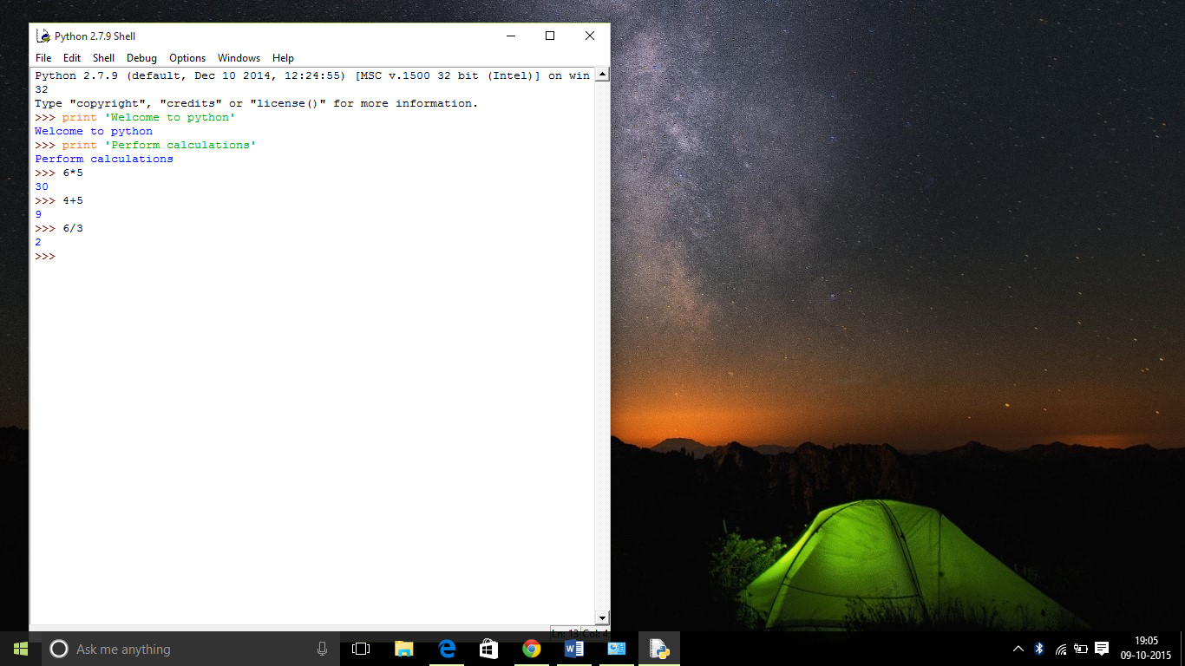

**Command Line interface**

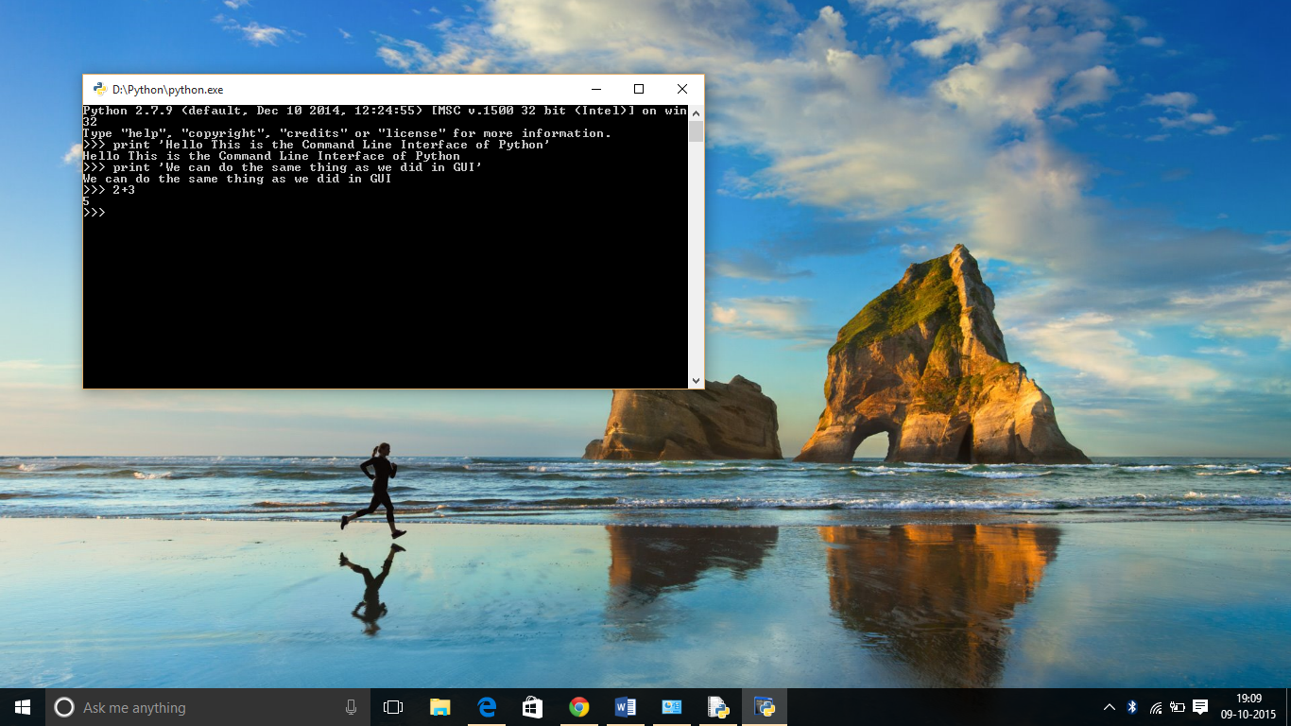

**Softwares making use of Python**

Python has been successfully embedded in a number of software products as a scripting language.

1. GNU Debugger uses Python as a **pretty printer** to show complex structures such as C++ containers.
2. Python has also been used in artificial intelligence
3. Python is often used for **natural language processing** tasks.

**Current Applications of Python**

1. A number of Linux distributions use installers written in Python example in Ubuntu we have the **Ubiquity**
2. Python has seen extensive use in the **information security industry**, including in exploit development.
3. Raspberry Pi– single board computer uses Python as its principal user-programming language.
4. Python is now being used **Game Development**areas also.

**Pros:**

1. Ease of use
2. Multi-paradigm Approach

**Cons:**

1. Slow speed of execution compared to C,C++
2. Absence from mobile computing and browsers
3. For the C,C++ programmers switching to python can be irritating as the language requires proper indentation of code. Certain variable names commonly used like sum are functions in python. So C, C++ programmers have to look out for these.

**Industrial Importance**

Most of the companies are now looking for candidates who know about Python Programming. Those having the knowledge of python may have more chances of impressing the interviewing panel. So I would suggest that beginners should start learning python and excel in it.

Python is a high-level, interpreted, and general-purpose dynamic programming language that focuses on code readability. It has fewer steps when compared to Java and C. It was founded in 1991 by developer Guido Van Rossum. Python ranks among the most popular and fastest-growing languages in the world. Python is a powerful, flexible, and easy-to-use language. In addition, the community is very active there. It is used in many organizations as it supports multiple programming paradigms. It also performs automatic memory management.

### **Advantages :**

1. Presence of third-party modules
   * built-in modules in Python. Some of the important ones are - collections, datetime, logging, math, numpy, os, pip, sys, and time etc.
   * third-party packages in Python include numpy , pandas , scikit-learn , matplotlib , tensorflow , django , flask , requests etc.
2. Extensive support libraries(NumPy for numerical calculations, Pandas for data analytics etc)
3. Open source and community development
4. Versatile, Easy to read, learn and write
5. User-friendly data structures
6. High-level language
7. Dynamically typed language(No need to mention data type based on the value assigned, it takes data type)
8. Object-oriented language
9. Portable and Interactive
10. Ideal for prototypes – provide more functionality with less coding
11. Highly Efficient(Python’s clean object-oriented design provides enhanced process control, and the language is equipped with excellent text processing and integration capabilities, as well as its own unit testing framework, which makes it more efficient.)
12. (IoT)Internet of Things Opportunities
13. Interpreted Language
14. Portable across Operating systems

## help() Function –

In Python, the help() function is a built-in function that provides information about

* + modules,
  + classes,
  + functions, and modules. In this article, we will learn about help function in [Python](https://www.geeksforgeeks.org/python-programming-language/).

[Link](https://www.geeksforgeeks.org/help-function-in-python/) - <https://www.geeksforgeeks.org/help-function-in-python/>

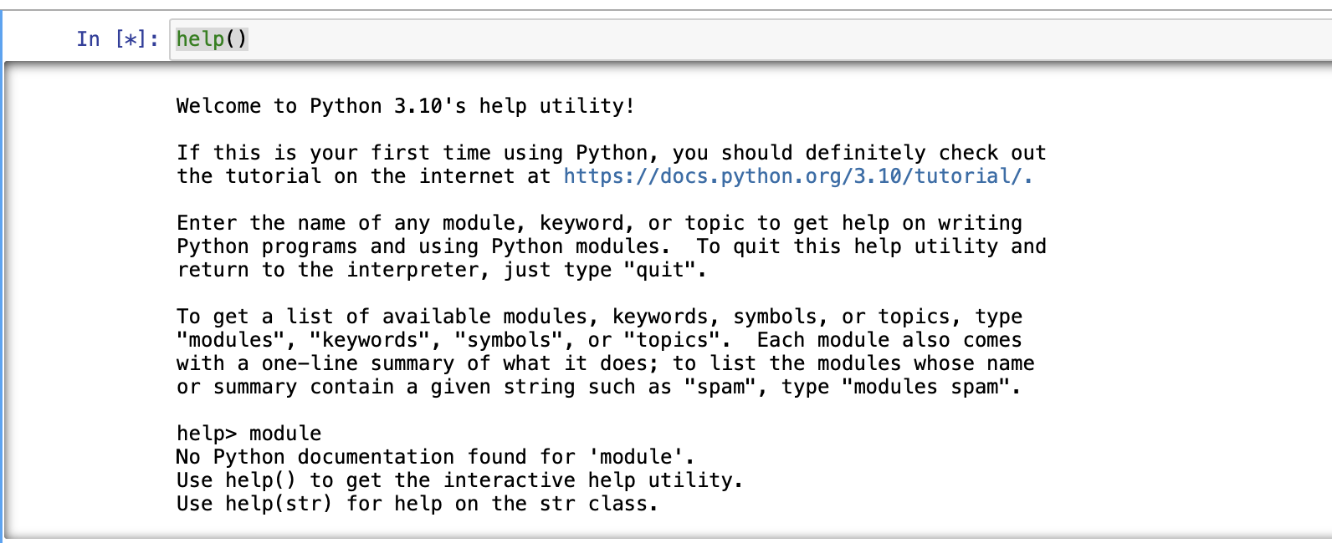

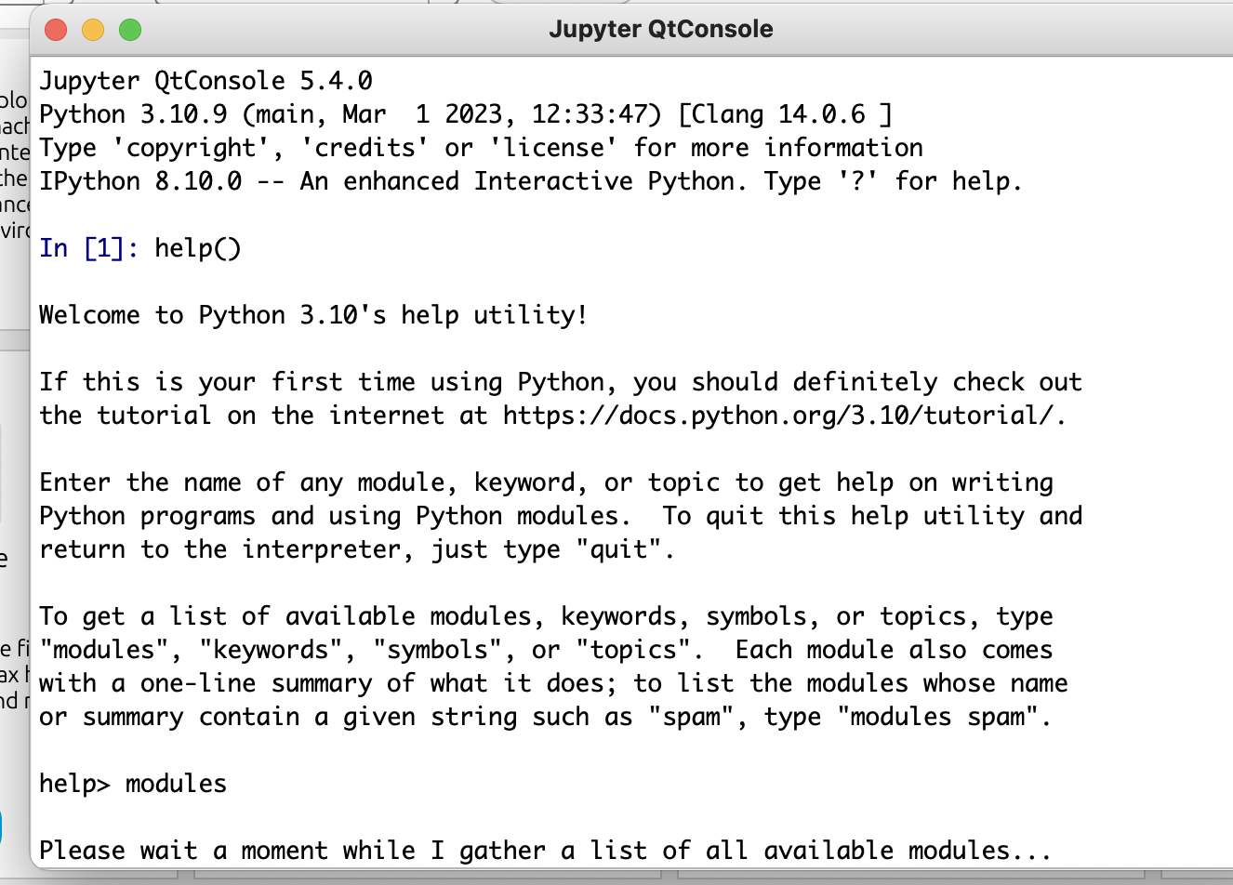

### **Applications :**

1. GUI based desktop applications
2. Graphic design, image processing applications, Games, and Scientific/ computational Applications
3. Web frameworks and applications
4. Enterprise and Business applications
5. Operating Systems
6. Education
7. Database Access
8. Language Development
9. Prototyping
10. Software Development

**Organizations using Python :**

1. Google(Components of Google spider and Search Engine)
2. Yahoo(Maps)
3. YouTube
4. Mozilla
5. Dropbox
6. Microsoft
7. Cisco
8. Spotify
9. Quora

So before moving on further.. let’s do the most popular ‘HelloWorld’ tradition  and hence compare Python’s Syntax with C, C++, Java ( I have taken these 3 because they are most famous and mostly used languages).

|  |
| --- |
| # Python code for "Hello World"  # nothing else to type...see how simple is the syntax.    print("Hello World") |

**Note:**Please note that Python for its scope doesn’t depend on the braces ( { } ),

instead it uses

- indentation for its scope.

Now moving on further **Lets start our basics of Python**. I will be covering the basics in some small sections. Just go through them and trust me you’ll learn the basics of Python very easily.

[Introduction and Setup](https://www.geeksforgeeks.org/python-language-introduction/)

1. If you are on **Windows OS** download Python by [Clicking here](https://www.python.org/downloads/windows/) and now install from the setup and in the start menu type IDLE.IDLE, you can think it as an Python’s IDE to run the Python Scripts.

It will look somehow this :  
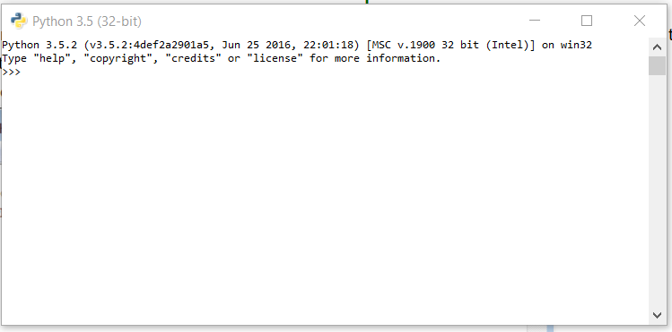

1. If you are on **Linux/Unix-like**just open the terminal and on 99% linux OS Python comes preinstalled with the OS.Just type ‘python3’ in terminal and you are ready to go.  
   It will look like this :  
   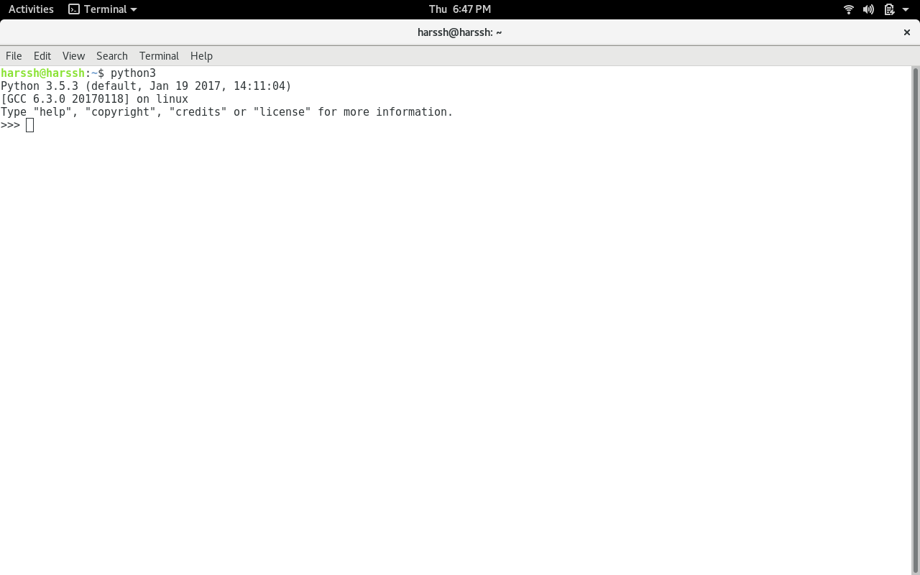

*CLI –*

*The ” >>> ” represents the python shell and its ready to take python commands and code.*